Project Design Phase-II

|  |  |
| --- | --- |
| Date | 11october2023 |
| Team ID | NM2023TMID345 |
| Name | Padma priya.E |
| Project name | Earthquake prediction model |

EARTHQUAKE PREDICTION MODEL

PHASE 2- INNOVATION

In this phase, we can explore innovative techniques such as ensemble methods and deep learning architectures to improve the prediction system's accuracy and robustness.

And also excuted advanced techniques such as hyperparameter tuning to improve the prediction model's performance.

**ENSEMBLE LEARNING (BAGGING)**

Ensemble learning in the context of earthquake prediction using bagging involves the use of multiple machine learning models, typically of the same type, to collectively make predictions about seismic events.

In bagging (Bootstrap Aggregating), multiple base models are trained on different subsets of the training data. Each subset is generated by sampling with replacement (bootstrapping) from the original dataset. This results in multiple diverse models, each having slightly different perspectives on the data.

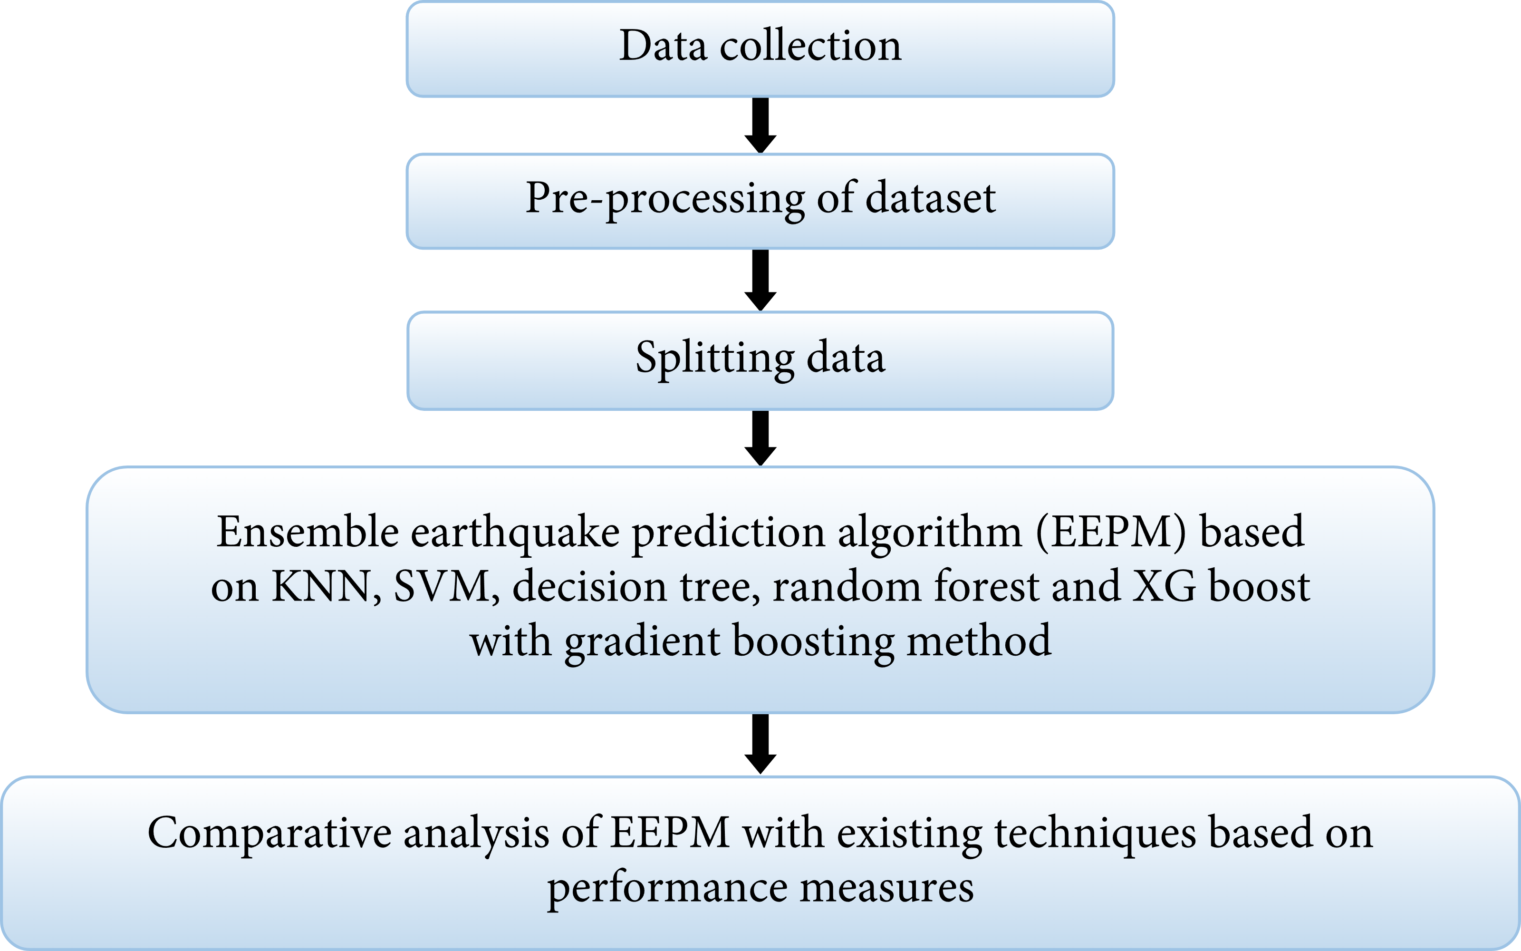

In the case of earthquake prediction, ensemble learning with bagging might involve training several models (e.g., decision trees, support vector machines, etc.) on different subsets of seismic data. These models would then independently predict seismic activity. The final prediction is typically determined through some form of aggregation, such as averaging the outputs for regression tasks or using voting for classification tasks.

The advantage of using bagging in earthquake prediction lies in its ability to reduce overfitting and increase the overall stability and accuracy of predictions. By combining the outputs of multiple models trained on slightly different data, the ensemble can capture a broader range of patterns and relationships in the seismic data, potentially leading to more reliable earthquake predictions.

**Common Architecture of Ensemble learning:**

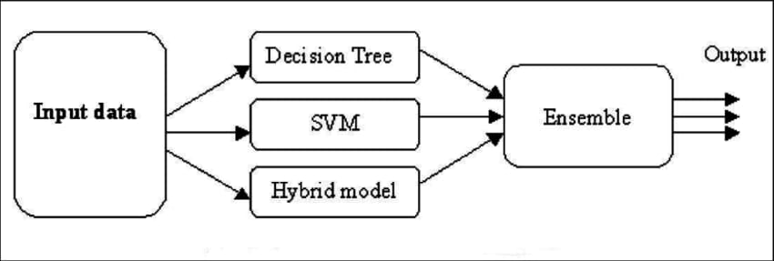

**Synthetic Dataset**: Earthquake Prediction

**Dataset Description**:

This synthetic dataset contains earthquake-related attributes for the purpose of prediction. It includes geographical coordinates, depth in kilometers, magnitude, and geological information.

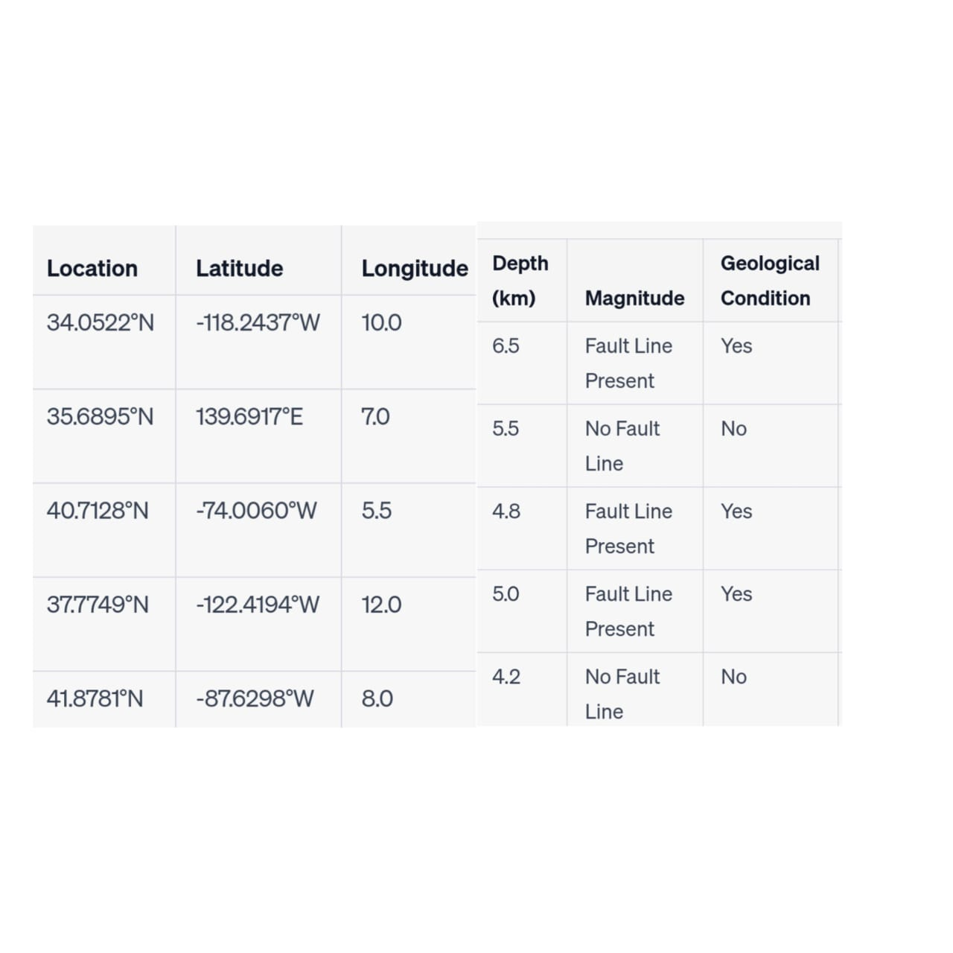

**Project Details:**

**Data Preprocessing:**

- Handle missing values.

- Detect and manage outliers.

- Standardize numerical features.

- Encode categorical variables (e.g., "Geological Condition").

**Feature Selection/Engineering:**

- Analyze dataset to identify relevant features.

- Potentially engineer new features (e.g., spatial relationships).

\***Model Selection:**

- Utilize the Bagging ensemble method for its effectiveness in improving prediction accuracy.

**Base Model Choice:**

- Employ decision trees as base models due to their capacity to handle non-linear relationships and interpretability.

example of using a Bagging ensemble with Decision Trees for earthquake prediction. We'll use the scikit-learn library in Python:

python

**# Import necessary libraries**

**from sklearn.ensemble import BaggingClassifier**

**from sklearn.tree import DecisionTreeClassifier**

**from sklearn.model_selection import train_test_split**

**from sklearn.metrics import accuracy_score**

**# Assume you have a dataset 'X' containing features and 'y' containing labels**

**# Split the data into training and testing sets**

**X_train, X_test, y_train, y_test = train_test_split(X, y, test_size=0.2, random_state=42)**

**# Initialize a Decision Tree Classifier**

**base_classifier = DecisionTreeClassifier()**

**# Initialize a Bagging Classifier with Decision Tree as base estimator**

**bagging_classifier = BaggingClassifier(base_estimator=base_classifier, n_estimators=10, random_state=42)**

**# Train the Bagging Classifier**

**bagging_classifier.fit(X_train, y_train)**

**# Predict using the trained model**

**y_pred = bagging_classifier.predict(X_test)**

**# Calculate accuracy**

**accuracy = accuracy_score(y_test, y_pred)**

**print(f"Accuracy: {accuracy}")**

**In this example:**

1. We first import the necessary libraries including the BaggingClassifier, DecisionTreeClassifier, and other relevant tools.

2. We assume you have a dataset `X` with features and `y` with corresponding labels.

3. We split the data into training and testing sets.

4. We initialize a Decision Tree Classifier as the base estimator.

5. Then, we initialize a Bagging Classifier with the Decision Tree as the base estimator and specify the number of estimators (trees) in the ensemble (in this case, 10).

6. We train the Bagging Classifier on the training data.

7. Next, we use the trained model to make predictions on the test data.

8. Finally, we calculate the accuracy of the model.

**Sample decision tree(**earth quake prediction**)**:

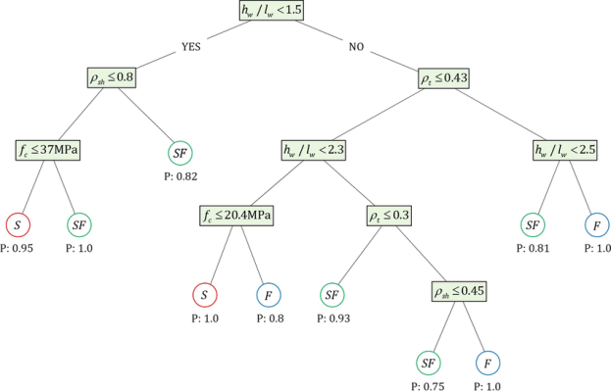

**Model Training:**

- Divide the dataset into training and testing sets.

- Train each base model on bootstrapped subsets of the data.

**Bagging Ensemble Creation:**

**-** Combine base models' predictions through techniques like averaging or voting.

**Model Evaluation:**

- Assess performance using metrics such as Mean Absolute Error (MAE) and Mean Squared Error (MSE).

- Consider specialized metrics like precision and recall for a comprehensive evaluation.

**Hyperparameter Tuning:**

- Fine-tune hyperparameters to optimize both base models and the ensemble.

Improving prediction using hyperparameter tuning in ensemble learning, specifically bagging, involves optimizing the parameters that control the behavior of the individual base learners and the ensemble as a whole.

**Select a Base Learner:**

- Choose a suitable base learner (e.g., decision trees, random forests, etc.) for bagging.

**Define Hyperparameters:**

- Identify the hyperparameters of the chosen base learner that can be tuned. For example, in a decision tree, you might want to tune parameters like max depth, minimum samples per leaf, etc.

**Set up a Validation Set:**

- Split your dataset into training, validation, and test sets. The validation set is used to evaluate the performance of different hyperparameter combinations.

**Grid Search or Random Search:**

- Perform a hyperparameter search using techniques like grid search or random search. Grid search exhaustively tries all combinations of a predefined set of hyperparameters, while random search randomly samples combinations.

**Evaluate Performance:**

- For each set of hyperparameters, train the base learner on the training set and evaluate its performance on the validation set using a suitable metric (e.g., accuracy, F1-score, etc.).

**Select the Best Hyperparameters:**

- Identify the combination of hyperparameters that gives the best performance on the validation set.

**Train the Ensemble:**

- Once you have the optimal hyperparameters for the base learner, train multiple instances of the base learner with different subsets of the training data (bagging). Each base learner should be trained with a different random subset.

**Aggregate Predictions:**

- Combine the predictions of individual base learners. For classification tasks, this could be done through voting or averaging.

**Evaluate on Test Set:**

- Finally, evaluate the performance of the ensemble on the test set to get an unbiased estimate of its predictive power.

**Monitor for Overfitting:**

- Keep an eye out for overfitting. If the ensemble performs significantly worse on the test set compared to the validation set, you might need to revisit your hyperparameter tuning process.

Remember to iterate and refine this process as needed. It's also worth considering techniques like cross-validation and bootstrapping to further validate the performance of your ensemble.

**Testing and Validation:**

- Validate model performance on a separate testing set to ensure generalizability.

**Visualization:**

- Create visualizations to display earthquake predictions.

- Compare predictions with actual occurrences.

- Show feature importance through visual aids.

**Control Flow for earthquake prediction:**

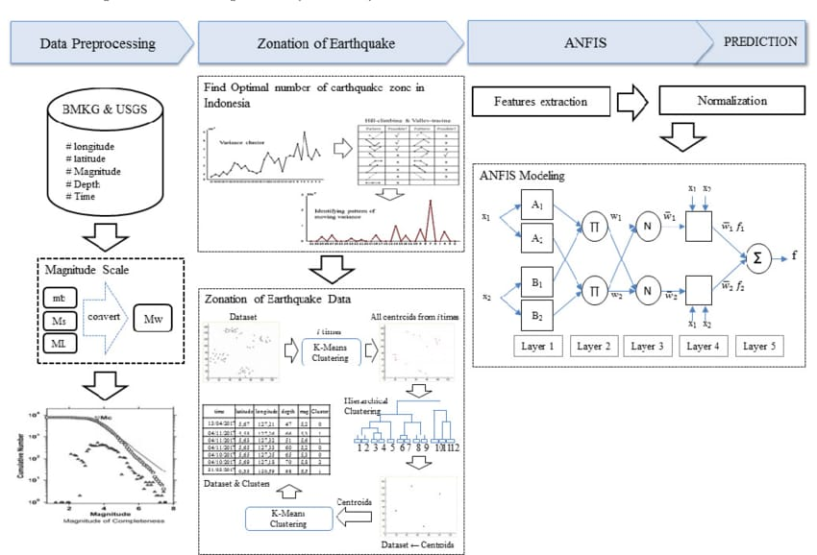

**Conclusion:**

In conclusion, this project endeavors to construct a potent earthquake prediction model using the Bagging ensemble method. Through meticulous data preprocessing, feature engineering, and astute model selection, we aim to forge a dependable tool for earthquake prediction. The evaluation metrics will furnish valuable insights into the model's efficacy, while visualizations will serve as a vital aid in comprehending the results.This comprehensive project is designed to showcase the efficacy of the Bagging ensemble technique in earthquake prediction, with a focus on data preprocessing, model selection, and rigorous evaluation.